Respond which target was **closer**.

time

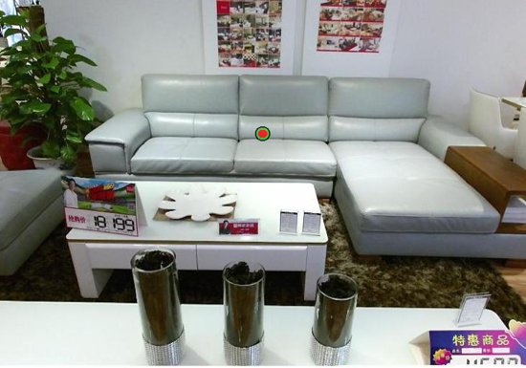

time

250 or 1000 ms

500 ms

500 ms

250 or 1000 ms

500 ms

500 ms

500 ms

Respond which target was **closer**.

**START**